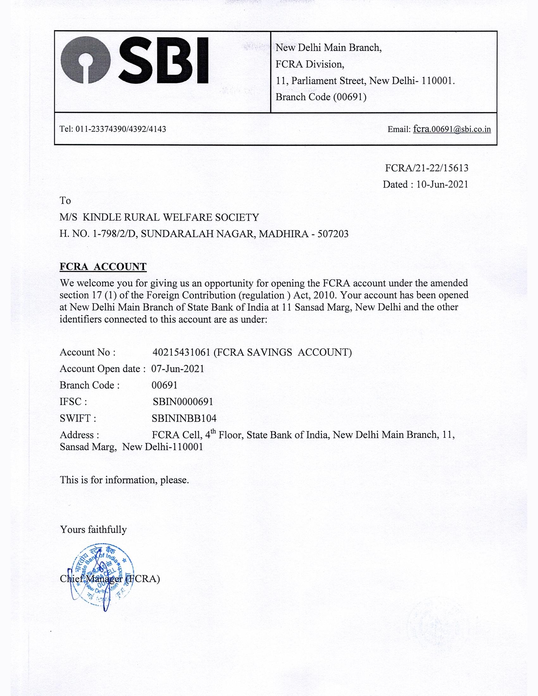

KINDLE RURAL WELFARE SOCIETY

SBI NEW DELHI MAIN BRANCH

SBI SAVING ACCOUNT NO: 40215431061

IFSC CODE : SBIN0000691

SWIIFT CODE: SBIN INBB104